# MOBILE APP DEVELOPMENET LAB

# Week 7

Program

Create an Android application using fragments.

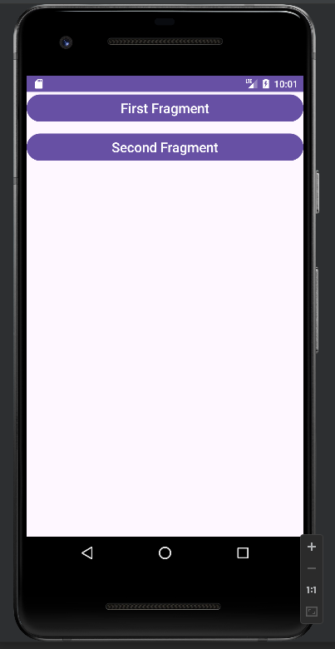 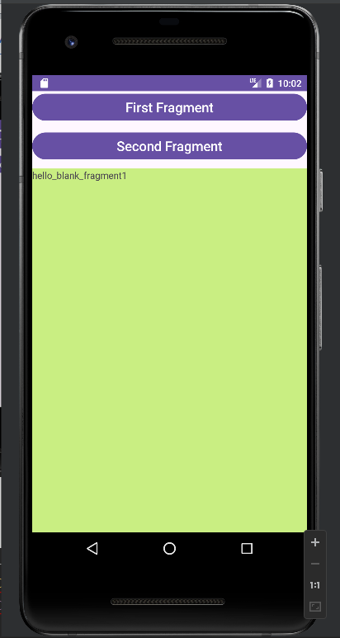 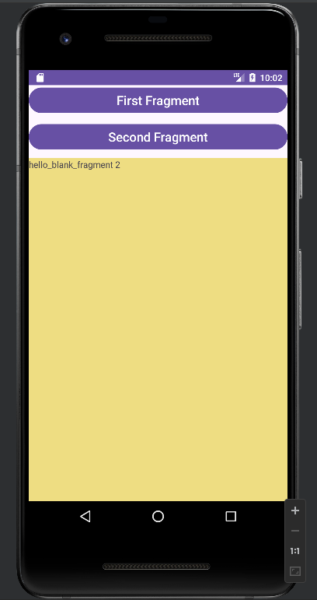

Activity_main.xml

<?xml version="1.0" encoding="utf-8"?>  
<LinearLayout xmlns:android="http://schemas.android.com/apk/res/android"  
 xmlns:app="http://schemas.android.com/apk/res-auto"  
 xmlns:tools="http://schemas.android.com/tools"  
 android:layout_width="match_parent"  
 android:layout_height="match_parent"  
 android:orientation="vertical"  
 tools:context=".MainActivity">  
  
  
 <Button  
 android:id="@+id/fstBtn"  
 android:layout_width="match_parent"  
 android:layout_height="wrap_content"  
 android:text="First Fragment"  
 android:textSize="20sp" />  
  
 <Button  
 android:id="@+id/SecBtn"  
 android:layout_width="match_parent"  
 android:layout_height="wrap_content"  
 android:layout_marginTop="10dp"  
 android:text="Second Fragment"  
 android:textSize="20sp" />  
  
 <FrameLayout  
 android:id="@+id/frameLayout"  
 android:layout_width="match_parent"  
 android:layout_height="match_parent"  
 android:layout_marginTop="10dp" />  
  
</LinearLayout>

MainActivity.java

package com.example.week_6_fragments;  
  
import androidx.appcompat.app.AppCompatActivity;  
import androidx.fragment.app.FragmentManager;  
import androidx.fragment.app.FragmentTransaction;  
import android.os.Bundle;  
import android.view.View;  
import android.widget.Button;  
public class MainActivity extends AppCompatActivity {  
 @Override  
 protected void onCreate(Bundle savedInstanceState) {  
 super.onCreate(savedInstanceState);  
 setContentView(R.layout.*activity_main*);  
 Button btnFirstFragment, btnSecondFragment;  
 // get the reference of Button's  
 btnFirstFragment = findViewById(R.id.*fstBtn*);  
 btnSecondFragment = findViewById(R.id.*SecBtn*);  
 // perform setOnClickListener event on First Button  
 btnFirstFragment.setOnClickListener(new View.OnClickListener() {  
 @Override  
 public void onClick(View v) {  
 FirstFragment firstFragment = new FirstFragment();  
  
 loadFragment(firstFragment);  
 }  
 });  
 // perform setOnClickListener event on Second Button  
 btnSecondFragment.setOnClickListener(new View.OnClickListener() {  
 @Override  
 public void onClick(View v) {  
 // load Second Fragment  
 loadFragment(new SecondFragment());  
 }  
 });  
 }  
  
 private void loadFragment(androidx.fragment.app.Fragment fragment) {  
 // create a FragmentManager  
 FragmentManager fm = getSupportFragmentManager();  
 // create a FragmentTransaction to begin the transaction and replace the Fragment  
 FragmentTransaction fragmentTransaction = fm.beginTransaction();  
 // replace the FrameLayout with new Fragment  
 fragmentTransaction.replace(R.id.*frameLayout*, fragment);  
 fragmentTransaction.commit(); // save the changes  
 }  
}

fragment_first.xml

<?xml version="1.0" encoding="utf-8"?>  
<FrameLayout xmlns:android="http://schemas.android.com/apk/res/android"  
 xmlns:tools="http://schemas.android.com/tools"  
 android:layout_width="match_parent"  
 android:layout_height="match_parent"  
 tools:context=".FirstFragment">  
  
 <!-- *TODO: Update blank fragment layout* -->  
 <TextView  
 android:layout_width="match_parent"  
 android:layout_height="match_parent"  
 android:text="hello_blank_fragment1" />  
  
</FrameLayout>

Fragment_second.xml

<?xml version="1.0" encoding="utf-8"?>  
<FrameLayout xmlns:android="http://schemas.android.com/apk/res/android"  
 xmlns:tools="http://schemas.android.com/tools"  
 android:layout_width="match_parent"  
 android:layout_height="match_parent"  
 tools:context=".SecondFragment">  
  
 <!-- *TODO: Update blank fragment layout* -->  
 <TextView  
 android:layout_width="match_parent"  
 android:layout_height="match_parent"  
 android:text="hello_blank_fragment 2" />  
  
</FrameLayout>